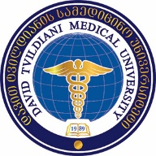
Sps daviT tvildianis samedicino universiteti

danarTi 1
damtkicebulia:
Sps ,,daviT tvildianis samedicino universiteti”-s
2018 wlis 18 ivnisis
reqtoris #27/a brZanebis Tanaxmad.

Sps ,,daviTYtvildianis samedicino universiteti”-s
reqtors

gancxadeba

saxeli

gvari

sakonkurso Tanamdeboba  (miuTiTeT erT-erTi) | - profesori  - asocirebuli profesori  - asistent-profesori
departamenti da/an marTuleba

ganmcxadeblis xelmowera ----------------------------------------------

TariRi “-------“ ---------------------------------------- 2018 w.

